**1. BookFinder.com**

Founded in 1997, BookFinder.com has become a leading book price comparison site. Find and compare hundreds of millions of new books, used books, rare books and out of print books from over 100,000 booksellers and 60+ websites worldwide. (div id)

<https://www.bookfinder.com/author/canada/>

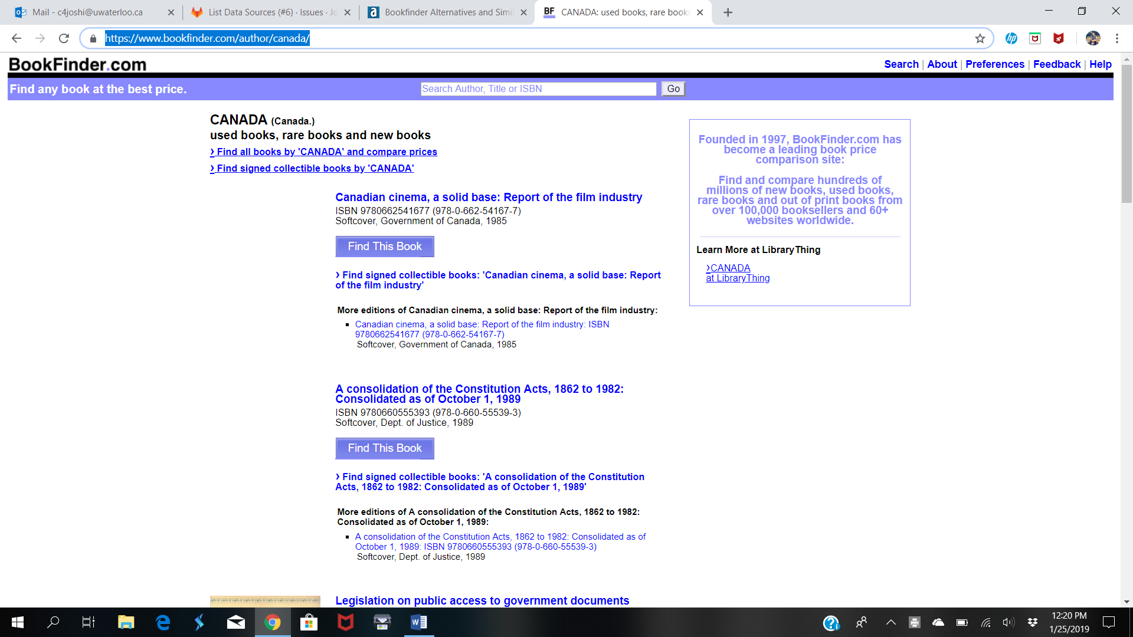

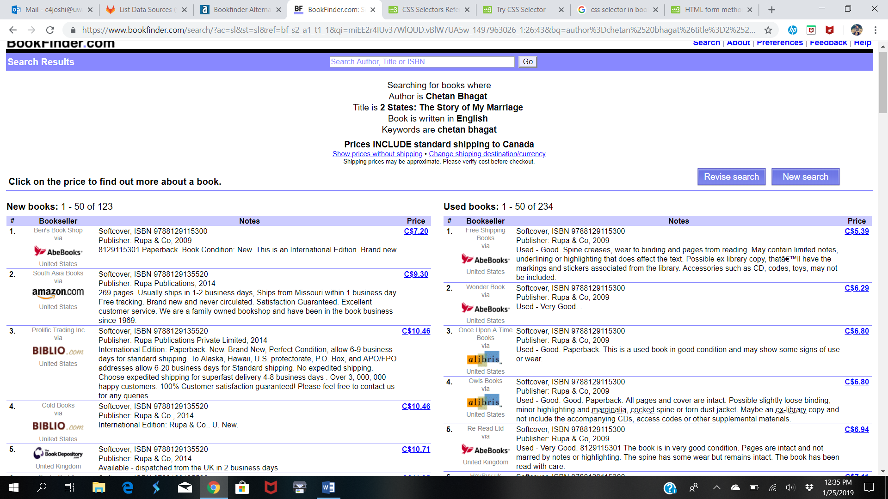

2. best buy

Features:

Store Locator , browse product, view past purchases, wish list, gift cards



3. Costco

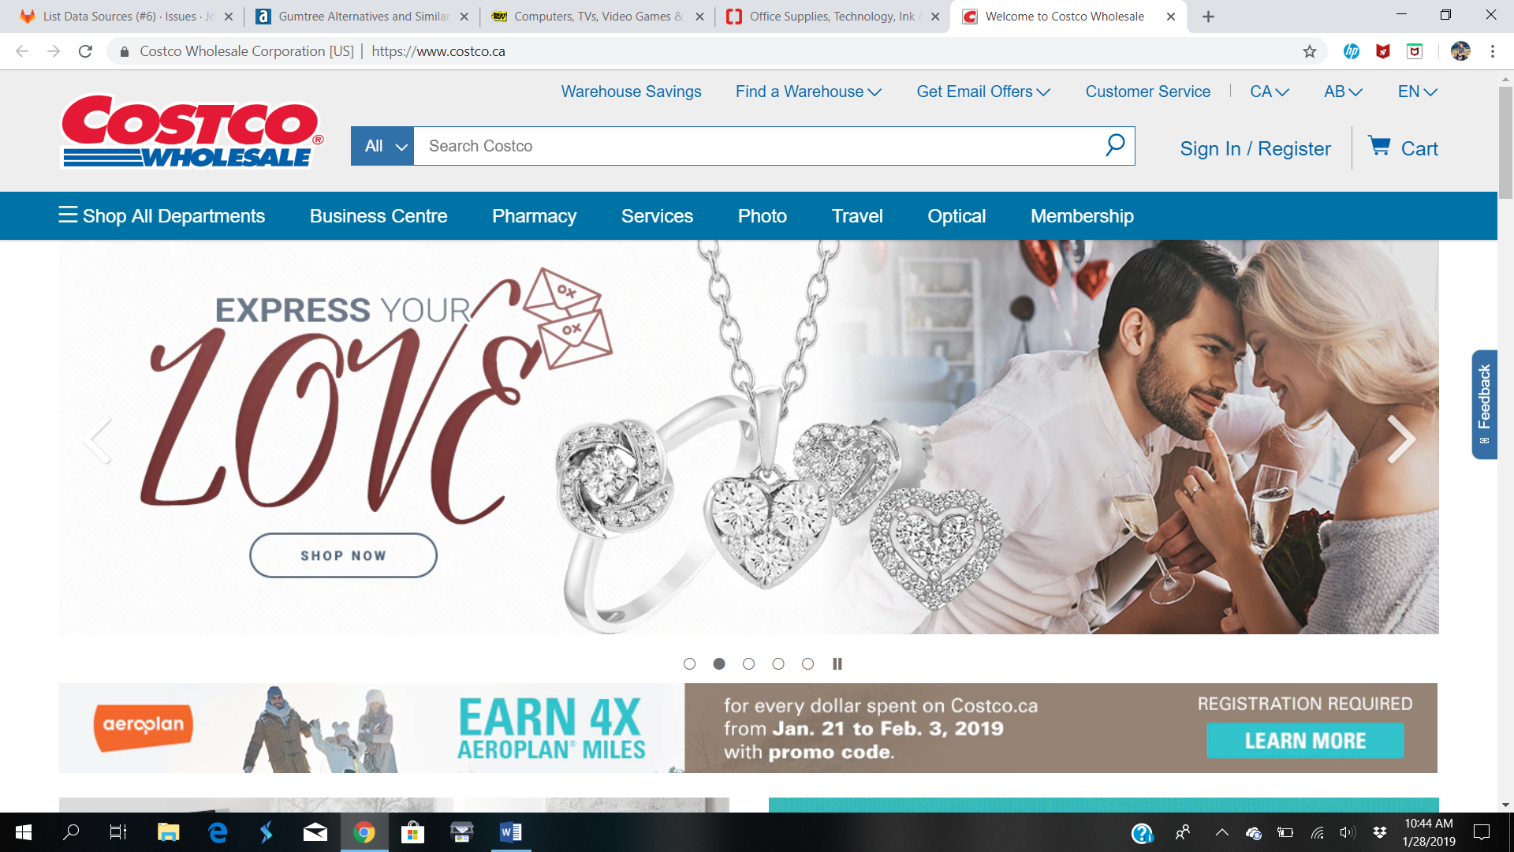

4.ebay

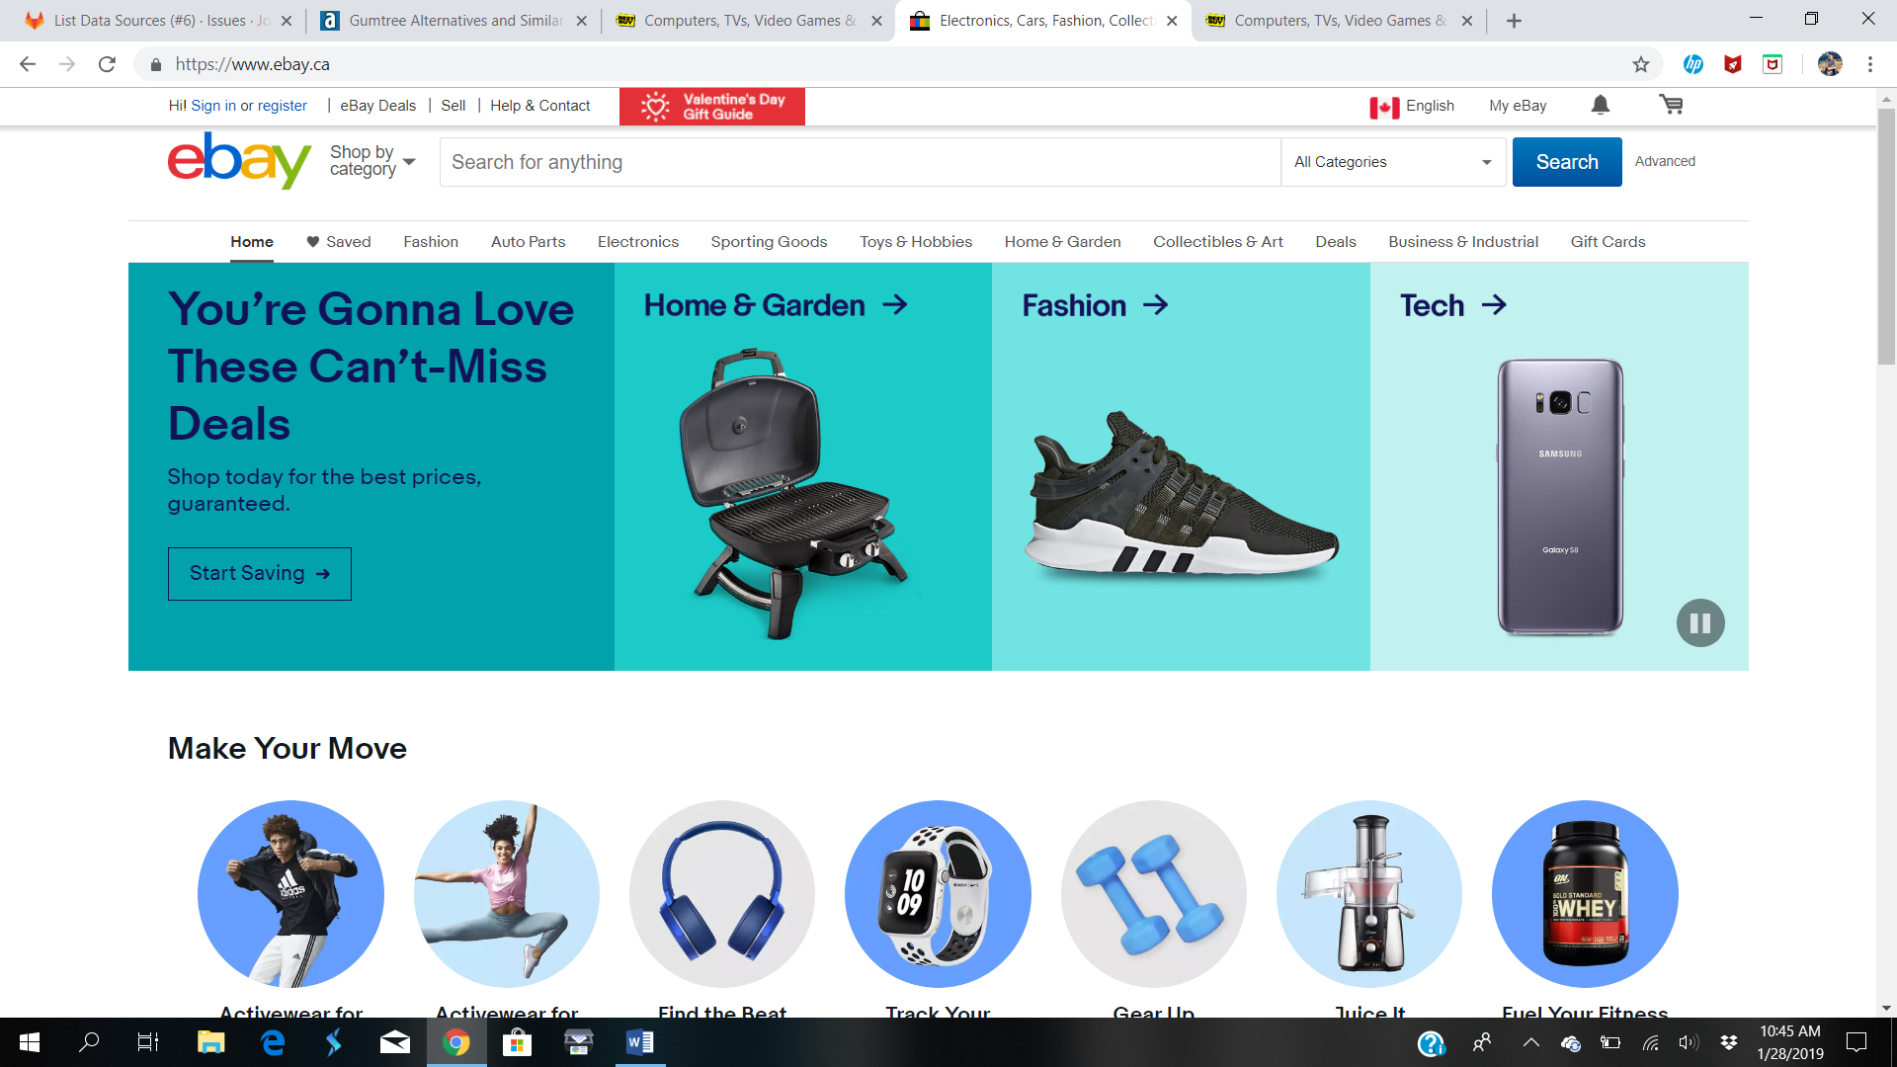

5. Staples

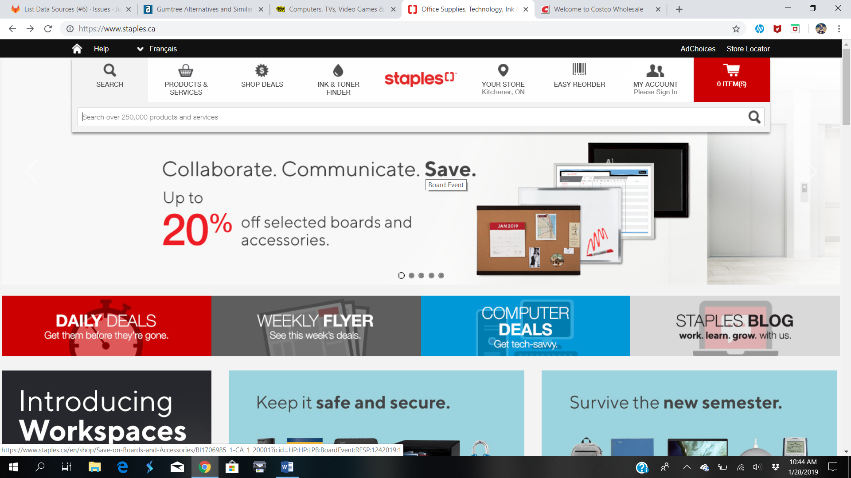

6. Walmart

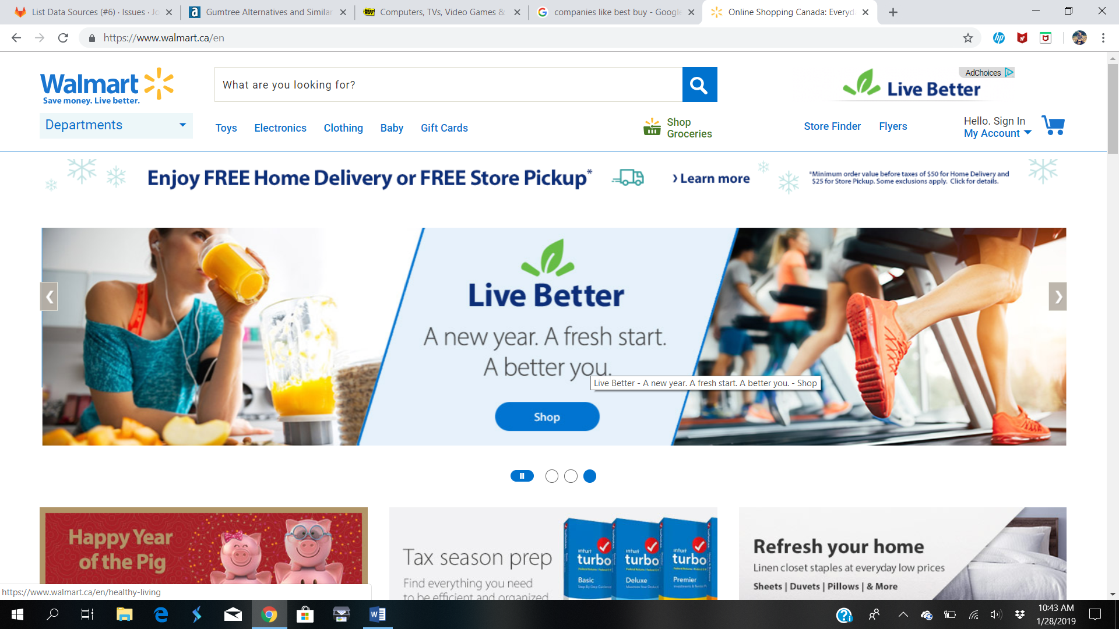

7. sobeys

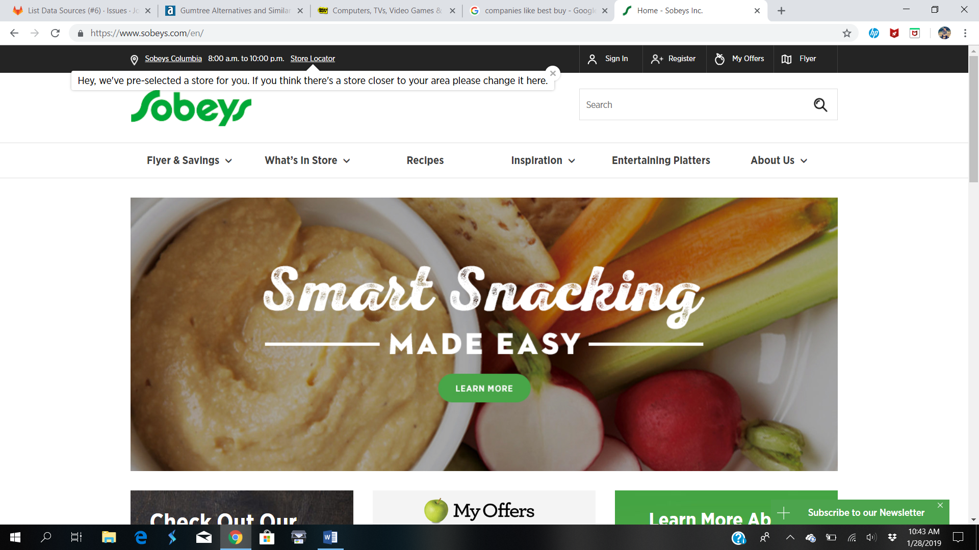

8. freshco

9. Nofrills

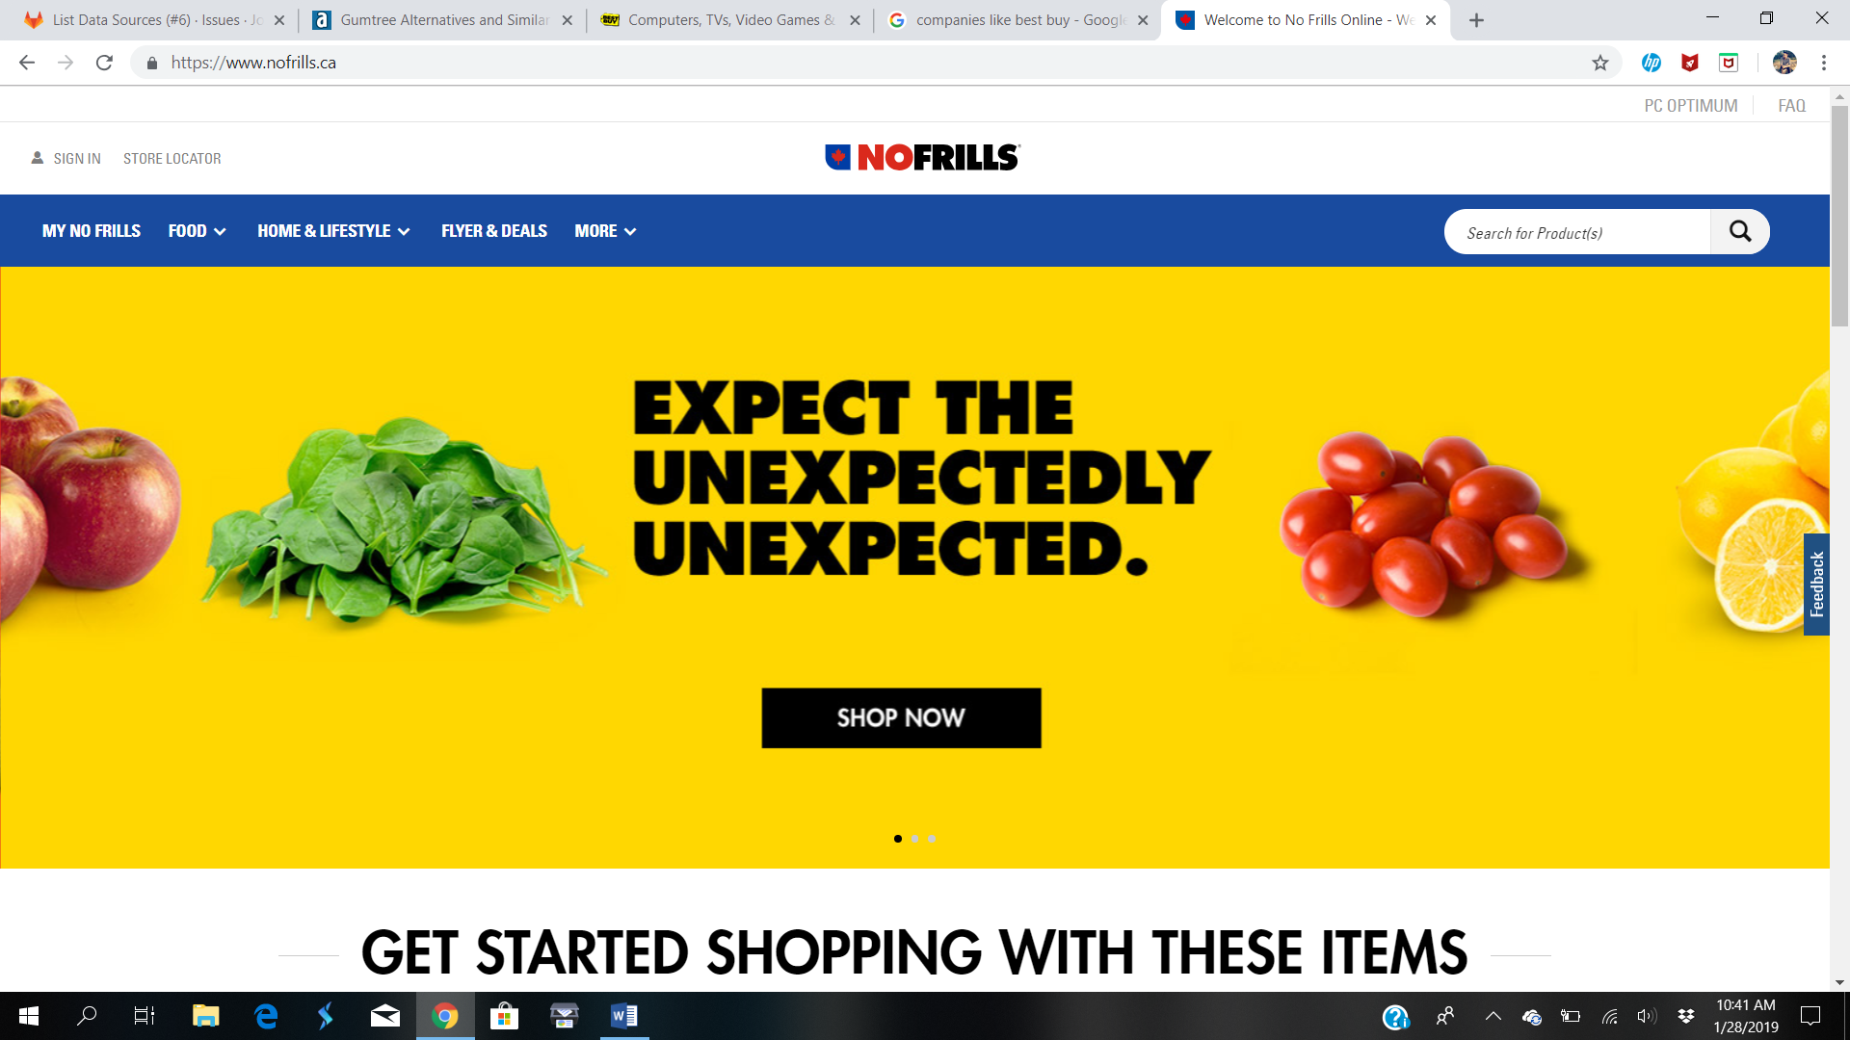

10. Newegg

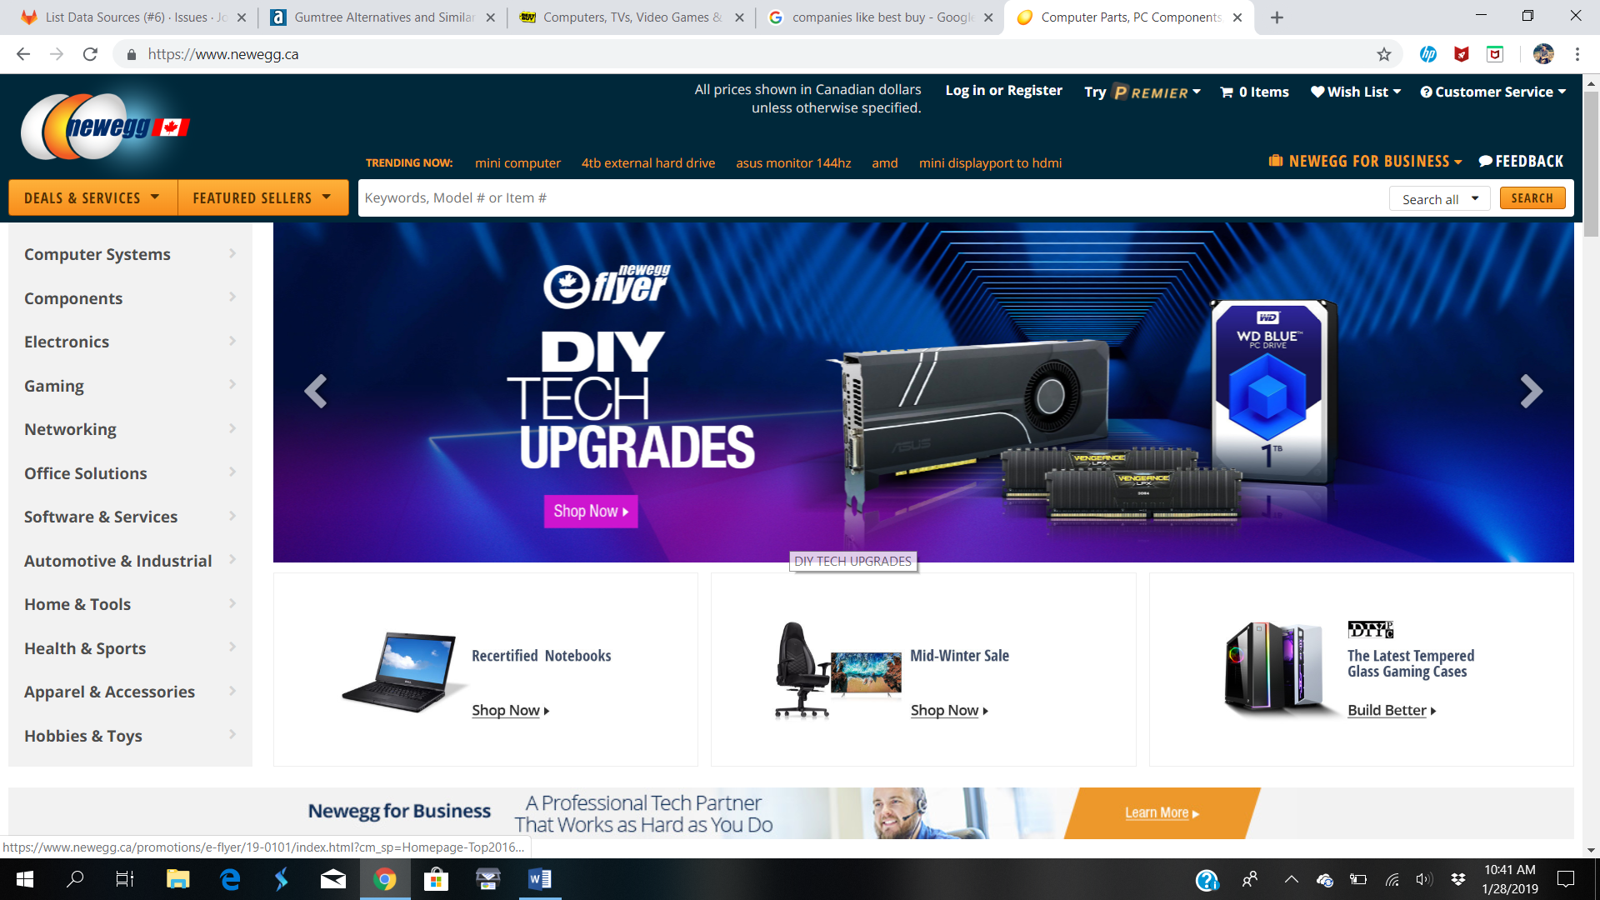

11. Aliexpress

